Контрольный срез знаний по английскому языку
по итогам 1 четверти
Вид речевой деятельности - ЧТЕНИЕ
1.Пояснительная записка
Класс: 8
Данная работа проводится с целью проверки сформированности навыков смыслового чтения и усвоения лексического и грамматического материла пройденного в 1 четверти по темам (разделам) «Модуль 1, 2», темы: «Социализация», «Еда и покупки».
Тест теста состоит из 3 заданий.
Максимально можно набрать 16 баллов.

2. Контролируемые элементы содержания
Задание | Проверяемые  навыки и умения
№ 1 | КЭС1. Чтение и понимание с использованием языковой, в том числе контекстуальной, догадки основного содержания несложных аутентичных текстов разных жанров и стилей.
№ 2 | КЭС2. Чтение с полным и точным пониманием несложных аутентичных текстов разных жанров и стилей, содержащих неизученные языковые явления
№ 3 | КЭС3.Выборочное понимание нужной / интересующей информации из  текста (просмотровое / поисковое чтение)

3. Ключи и критерии оценивания
За каждый правильный ответ ученик получает 1 балл. В таблице, приведенной выше, указывается количество баллов,которые обеспечивают получение оценки «5», «4», «3» за каждое задание. Если ученик набрал меньше баллов, чем указано в таблице, — это означает, что его оценка за данное задание «неудовлетворительно» и данные навыки и умения сформированы недостаточно хорошо.
Оценка | «2» | «3» | «4» | «5»
Вариант 1
Баллы | 8 и меньше | 9-11 | 12-13 | 14-16
Вариант 2
Баллы | 8 и меньше | 9-11 | 12-13 | 14-16

Вариант 1
Задание №1
1 | 2 | 3 | 4 | 5 | 6
NS | T | F | F | NS | T
Задание №2
A | B | C | D | E
3 | 5 | 1 | 6 | 2
Задание №3.
A | B | C | D | E
2 | 4 | 3 | 1 | 3

Вариант 2
Задание №1
1 | 2 | 3 | 4 | 5 | 6
T | T | F | F | T | NS
Задание №2
A | B | C | D | E
4 | 6 | 1 | 5 | 3

Задание№3
A | B | C | D | E
1 | 4 | 3 | 2 | 1

Variant 1
Task 1.
Read the text and mark the statements as true (T), false (F) or not stated (NS).
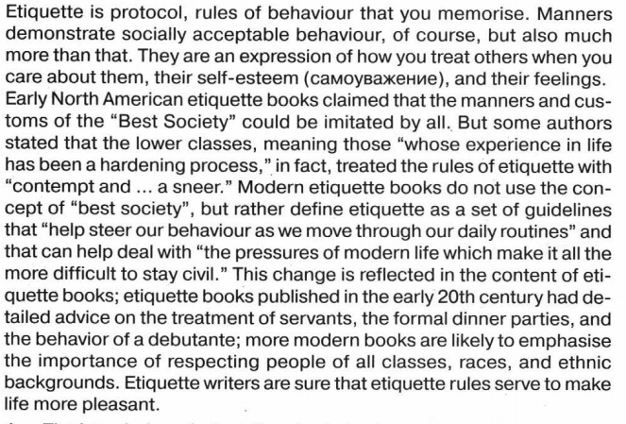
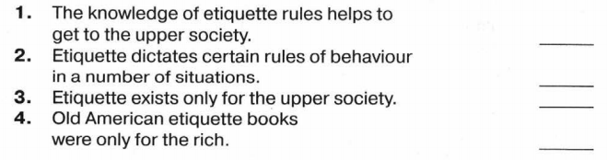
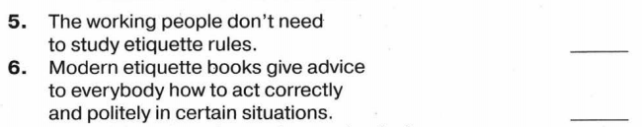

Task 2 .



Ответ:
A | B | C | D | E

Task 3.
Read the text. Прочитайте рассказ. Подберите к каждому из предложений A-E одно верное утверждение из списка четырёх вариантов (1, 2, 3 или 4).
A Missed Concert
At last, this day has come, and Mary is practically buzzing with excitement. She’s
been counting down the days for what feels like ages, and today is supposed to be
epic. Her favorite band, the one she listens to on repeat, is playing just a few blocks
away . Mary can already imagine herself singing along, dancing with her friends and
just soaking in the atmosphere of pure music pleasure. Everything seemed perfect
— until it happened.
That morning, though, Mary woke up with a strange feeling. At first, she thought
it was just a case of nerves or maybe a bit of a stomach ache from all those snacks
she had been eating in anticipation. However, as the hours passed, her excitement
slowly turned into worry . Her head was pounding, and her body felt heavier than
usual. When her mum came in to check her temperature, the expression on her
face said it all: Mary was definitely going to miss the concert of her dreams.
As she lay there, scrolling through social media, each post about the concert felt
like a pain in her heart. Friends were posting group selfies, excitement practically
radiating from the screen, and every notification was a reminder of what she was
missing. The thought of her favorite band playing live just two steps away from her,
while Mary was stuck in bed, made her feel even worse. It was like watching a
movie where all the best parts happened without her . Mary couldn’t help but feel a
little envy toward everyone else who was having the night of their lives without her .
But even in her disappointment, Mary remembered her friends that were
attending. She texted them to enjoy and promised she’d catch up with them later to
hear all about it. Mary’s mum supported her and said that sometimes life brought
unexpected surprises, but Mary should understand that there would always be
another concert, another chance to break away with her favorite band. Mary vowed
that once she was better, she would definitely get tickets for the next show, no
matter what. And until then, she had a whole playlist of their songs to hold on.

A. Mary was waiting for that day because of …
1) her birthday .
2) a big musical event.
3) a friends gathering.
4) a school event.
B. Mary experienced … that made her worry about missing the concert.
1) dizziness and fatigue.
2) coughing and sneezing.
3) a sore throat.
4) a headache and body aches.

C. Choose the true sentence.
1) She felt happy for her friends.
2) She felt angry and resentful.
3) She felt sad and envy .
4) She ignored them completely .

D. Mary’s mum advised her …
1) to wait for another chance.
2) to forget about the concert.
3) to go to the concert anyway .
4) to stay in bed and rest.

E. Once she felt better Mary decided …
1) to stay home and rest.
2) to catch up with her friends immediately .
3) to get tickets for the next show.
4) to stop listening to her favorite band.

Занесите в таблицу номера ответов под буквами.
Ответ:
A | B | C | D | E

Variant 2
Task 1.
Read the text and mark the statements as true (T), false (F) or not stated (NS).
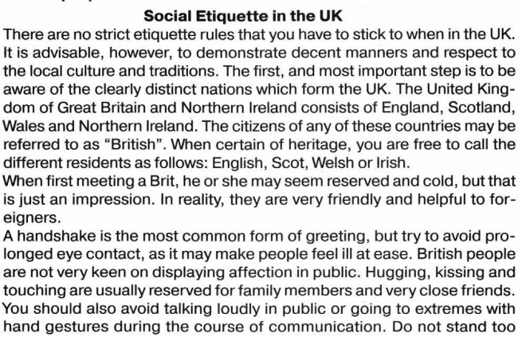
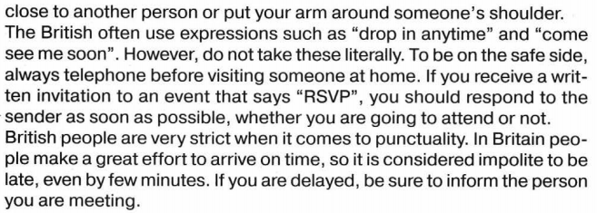
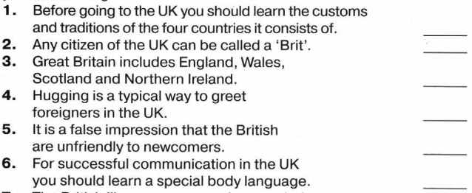

Task 2.
Вы проводите информационный поиск в ходе выполнения проектной работы.
Определите, в каком из текстов A–F содержатся ответы на
интересующие Вас вопросы 1–7. Один из вопросов останется без ответа.
Занесите Ваши ответы в таблицу.

1. What nature-friendly ideas started a new branch in the tourism business?
2. What means of transport is the most popular with tourists?
3. Why can tourism be dangerous to nature?
4. What are the reasons that make people go on a trip?
5. What kind of tourism is getting popular with elderly people?
6. Why does travelling make people smarter?

A.Tourism has become a popular activity. Indeed, nowadays people travel more,
and further, than they used to. The main reasons for tourism are: recreation,
leisure and business. When travelling for recreation, people want to escape
their stressful daily routine and to relax. Beach holidays are an example of such
tourism. Business trips involve going to a distant place in order to settle
business issues.
B.Whether on a business trip or on a honeymoon, people want to explore the
place they are in. They go on excursions, try new activities like diving or
mountain climbing and learn about the historical background of the place and
its cultural peculiarities. Sometimes they find out amazing facts about people
and places and about themselves too! In fact, when people travel, they broaden
their horizons.
C.A new branch of tourism is ecotourism. It involves visiting relatively
untouched places in remote areas. Ecotourism is often misinterpreted as any
form of tourism involving wildlife – but it’s completely different from jungle
tourism or safari. Eco-tourists are against disturbing the environment; even
taking photos is not recommended. Take only memories and leave only
footprintsis a very popular slogan for them.
D.By educational tourism, most people mean different versions of Learn and
Travel Programmes for students. But it’s not only for the young and brave.
Lots of training and educational programmes for adults are offered in different
corners of the world. Retired people participate in these programmes too. They
gladly enroll on overseas courses ranging from gardening and design to
computer skills and programming.
E.If possible, consider means of transport other than the plane. Rapidly
increasing numbers of flights have put the environment in danger. Planes
pollute the air, which results in global warming. In fact, tourism is not
harmless fun as many may think: new airports and tourist infrastructure,
pollution and crowds of noisy tourists make wild animals migrate, which may
decrease their population oreven make them extinct.

Текст | A | B | C | D | E
Вопрос

Task 3.
Прочитайте рассказ. Подберите к каждому из предложений A-E одно верное
утверждение из списка четырёх вариантов (1, 2, 3 или 4).
A Chance Of A Lifetime
George was a typical high school student. One morning he had a usual routine
— ate some cereal, put on his favorite hoodie and then rushed to school. When
George entered the cafeteria, he noticed a huge banner hanging above the food line
that read, "Battle of Talents - Sign Up Now!“ Today his school was hosting a contest
for a chance to win a summer internship at a local music studio. George played the
guitar in his spare time and dreamt of becoming a music producer, but he never
thought a simple contest could be his ticket to the big leagues.
His heart raced; he imagined his name in bright lights. He knew he had to try
but felt those familiar butterflies fluttering in his stomach. What if he crashed and
burned? After a moment of hesitation his friends pushed him to sign up, and before
he knew it, he was standing on stage with the guitar in his hands, looking at the sea
of faces. As he played, something magical happened; the nerves melted away, and
he was in his element, playing every note and stress with passion.
As the last chord sounded, George was greeted with thunderous applause.
It was like a wave of pure adrenaline crashing over him, and at that moment, he felt
invincible. But the true exciting part of the story was when the head of the music
studio, who judged the contest, approached him afterward. “You’ve got something
special, guy . We are happy to invite you to our summer musical course” he said.
It was at that moment when George realized that was more than just a school event
— it was his chance to make his dreams come true!
In the following weeks, George combined rehearsals with schoolwork,
determined to make the most of this wonderful opportunity . He put his heart and
soul into every practice session, building friendships with his bandmates and
absorbing every bit of knowledge they shared. By the end of the summer, George
had left not just with newfound skills and connections; he had left with a fire lit in
him that would shape his future.

A. Winning in the contest provides …
1) a training at a music studio.
2) a chance to perform at a concert.
3) a scholarship for college.
4) a recording contract.
B. George played …
1) a wind instrument.
2) a keyboard instrument.
3) an electronic instrument.
4) a string instrument.
C. Before going on stage George felt …
1) confident.
2) indifferent.
3) nervous.
4) angry .
D. … approached George after his performance.
1) his friends.
2) the head of the music studio.
3) the school principal.
4) his music teacher .
E. The words “with a fire lit in him” mean that …
1) he felt enthusiastic.
2) he felt depressed.
3) he felt unpleased.
4) he felt angry .

Занесите в таблицу номера ответов под буквами.

A | B | C | D | E

